www.Elitechemist.com
Please Stop paying too much for your medicine
Serch options like : good rx
Colour like : https://skinorac.com/
No Big conditions savings with Elitechemist.
Compare prices all online pharmacy
Contact us page like : alldaychemist.com

Logo


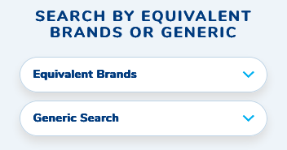

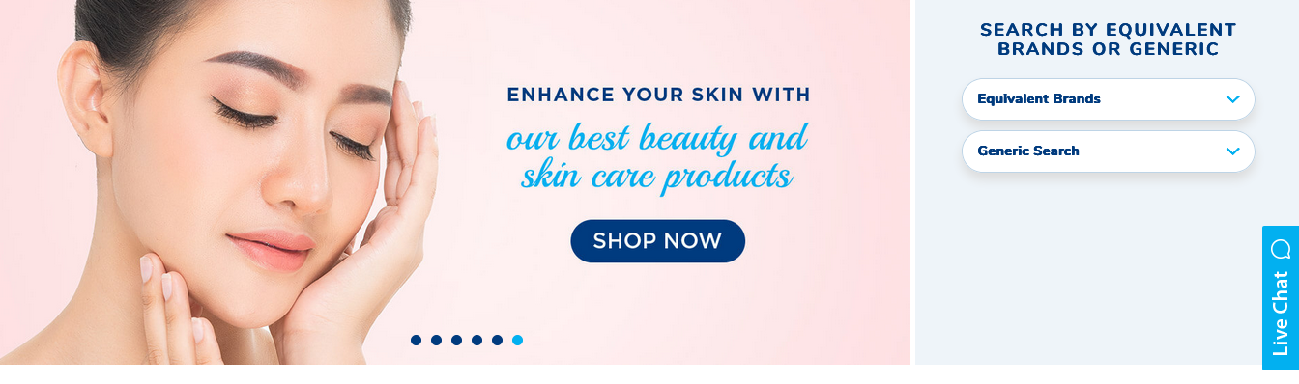

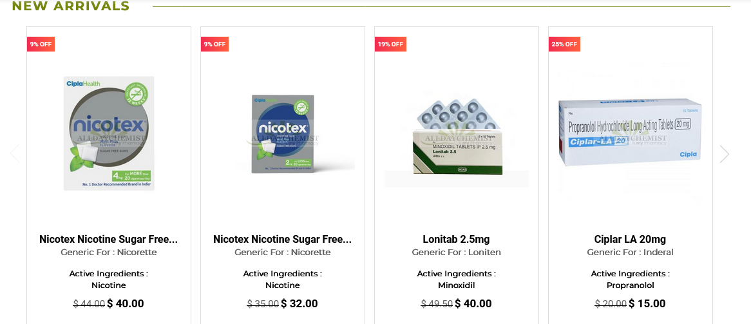
Product category redirect on category page
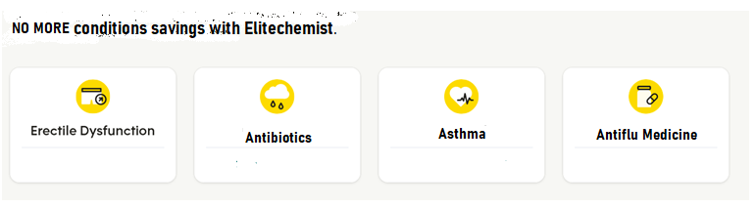



HCG baner with redricet to HCG category

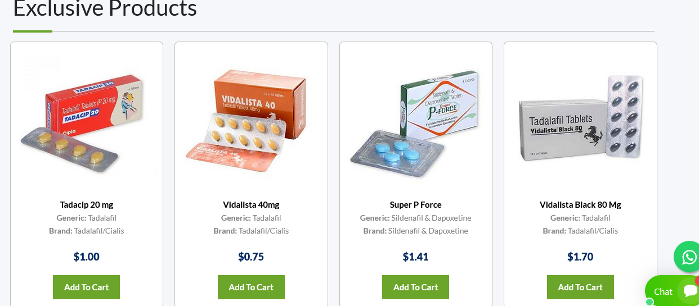



One section

ALL TAB IN FOOTER

